Guidelines for Preparing 2-Page Extended Abstracts
First Author¹, Second Author² and Third Author^{2,*}
¹Institute1, ISRO – 695022, India
²Institute2, IITD – 110016, India
*Communicating Author, E-Mail: abc@xyz.ac.in
- Introduction
This document describes the format for the 2-page extended abstract to be presented in the 7th National Finite Element/ FEAST^{SMT} Developers’/Users’ Meet (NAFED 07) to be held at IIT Delhi, on March 25th, 2023. It is our goal to maintain a reasonable degree of consistency between papers in the final proceedings/product. This document has been created in the required format. It can therefore be used as a template by simply typing over the existing contents of the file.
The extended abstracts are strictly limited to two pages, which will be published in the Extended Abstract Volume for distribution among the congress participants, if accepted.
  - Problem Description
Please note that the first paragraph of a section or subsection is not indented. The first paragraphs that follows a table, figure, equation etc. does not have an indent, either.

Subsequent paragraphs, however, are indented.

Sample Heading (Third Level).Only two levels of headings should be numbered. Lower level headings remain unnumbered; they are formatted as run-in headings.

Sample Heading (Forth Level).The contribution should contain no more than four levels of headings.

The following Table 1shows how a table should look like in the abstract.

Table 1 Sample Table
Column 1 | Column 2
1 | Contents
. | …
For citations of references, we prefer the use of square brackets and consecutive numbers. Citations using labels or the author/year convention are also acceptable. The following bibliography provides a sample reference list with entries for journal articles [1], an LNCS chapter [2], a book [3], proceedings without editors [4], as well as a URL [5].

  - Modeling in FEAST^{SMT} software
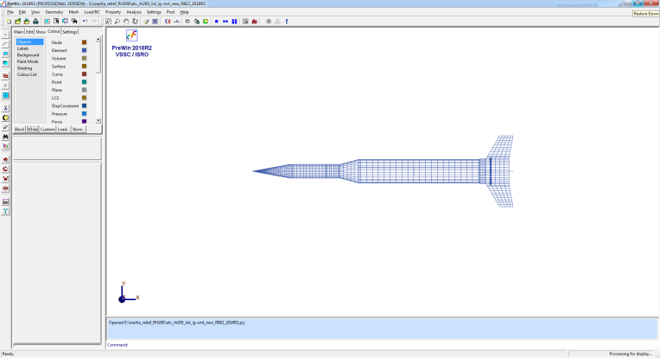
Fig. 1. A figure caption is always placed below the illustration. Short captions are centered, while long ones are justified.
- Results & Discussions
Whenever possible, use vector graphics instead (seeFig.2).

Fig. 2. A figure caption is always placed below the illustration. Short captions are centered, while long ones are justified.

References
- Author, F.: Article title. Journal 2(5), 99–110 (2016).
- Author, F., Author, S.: Title of a proceedings paper. In: Editor, F., Editor, S. (eds.) CONFERENCE 2016, LNCS, vol. 9999, pp. 1–13. Springer, Heidelberg (2016).
- Author, F., Author, S., Author, T.: Book title. 2nd edn. Publisher, Location (1999).
- Author, F.: Contribution title. In: 9th International Proceedings on Proceedings, pp. 1–2. Publisher, Location (2010).
- http://www.springer.com/lncs, last accessed 2016/11/21.

